Young Miss Arkansas
24thAnnual Open State Pageant
May 9th, 2020 at the Westside Fine Arts Center, Westside High School 1630 Hwy 91 West, Jonesboro AR. Registration will be from
2:00 pm to 2:45 pm with the first division starting at 3:00 pm.

The 2019 returning Queens are not eligible to compete. Compete age day of Pageant
MODELING IS NOT SCORED AT THIS PAGEANT!!!!!!! ATTIRE IS FORMAL WEAR
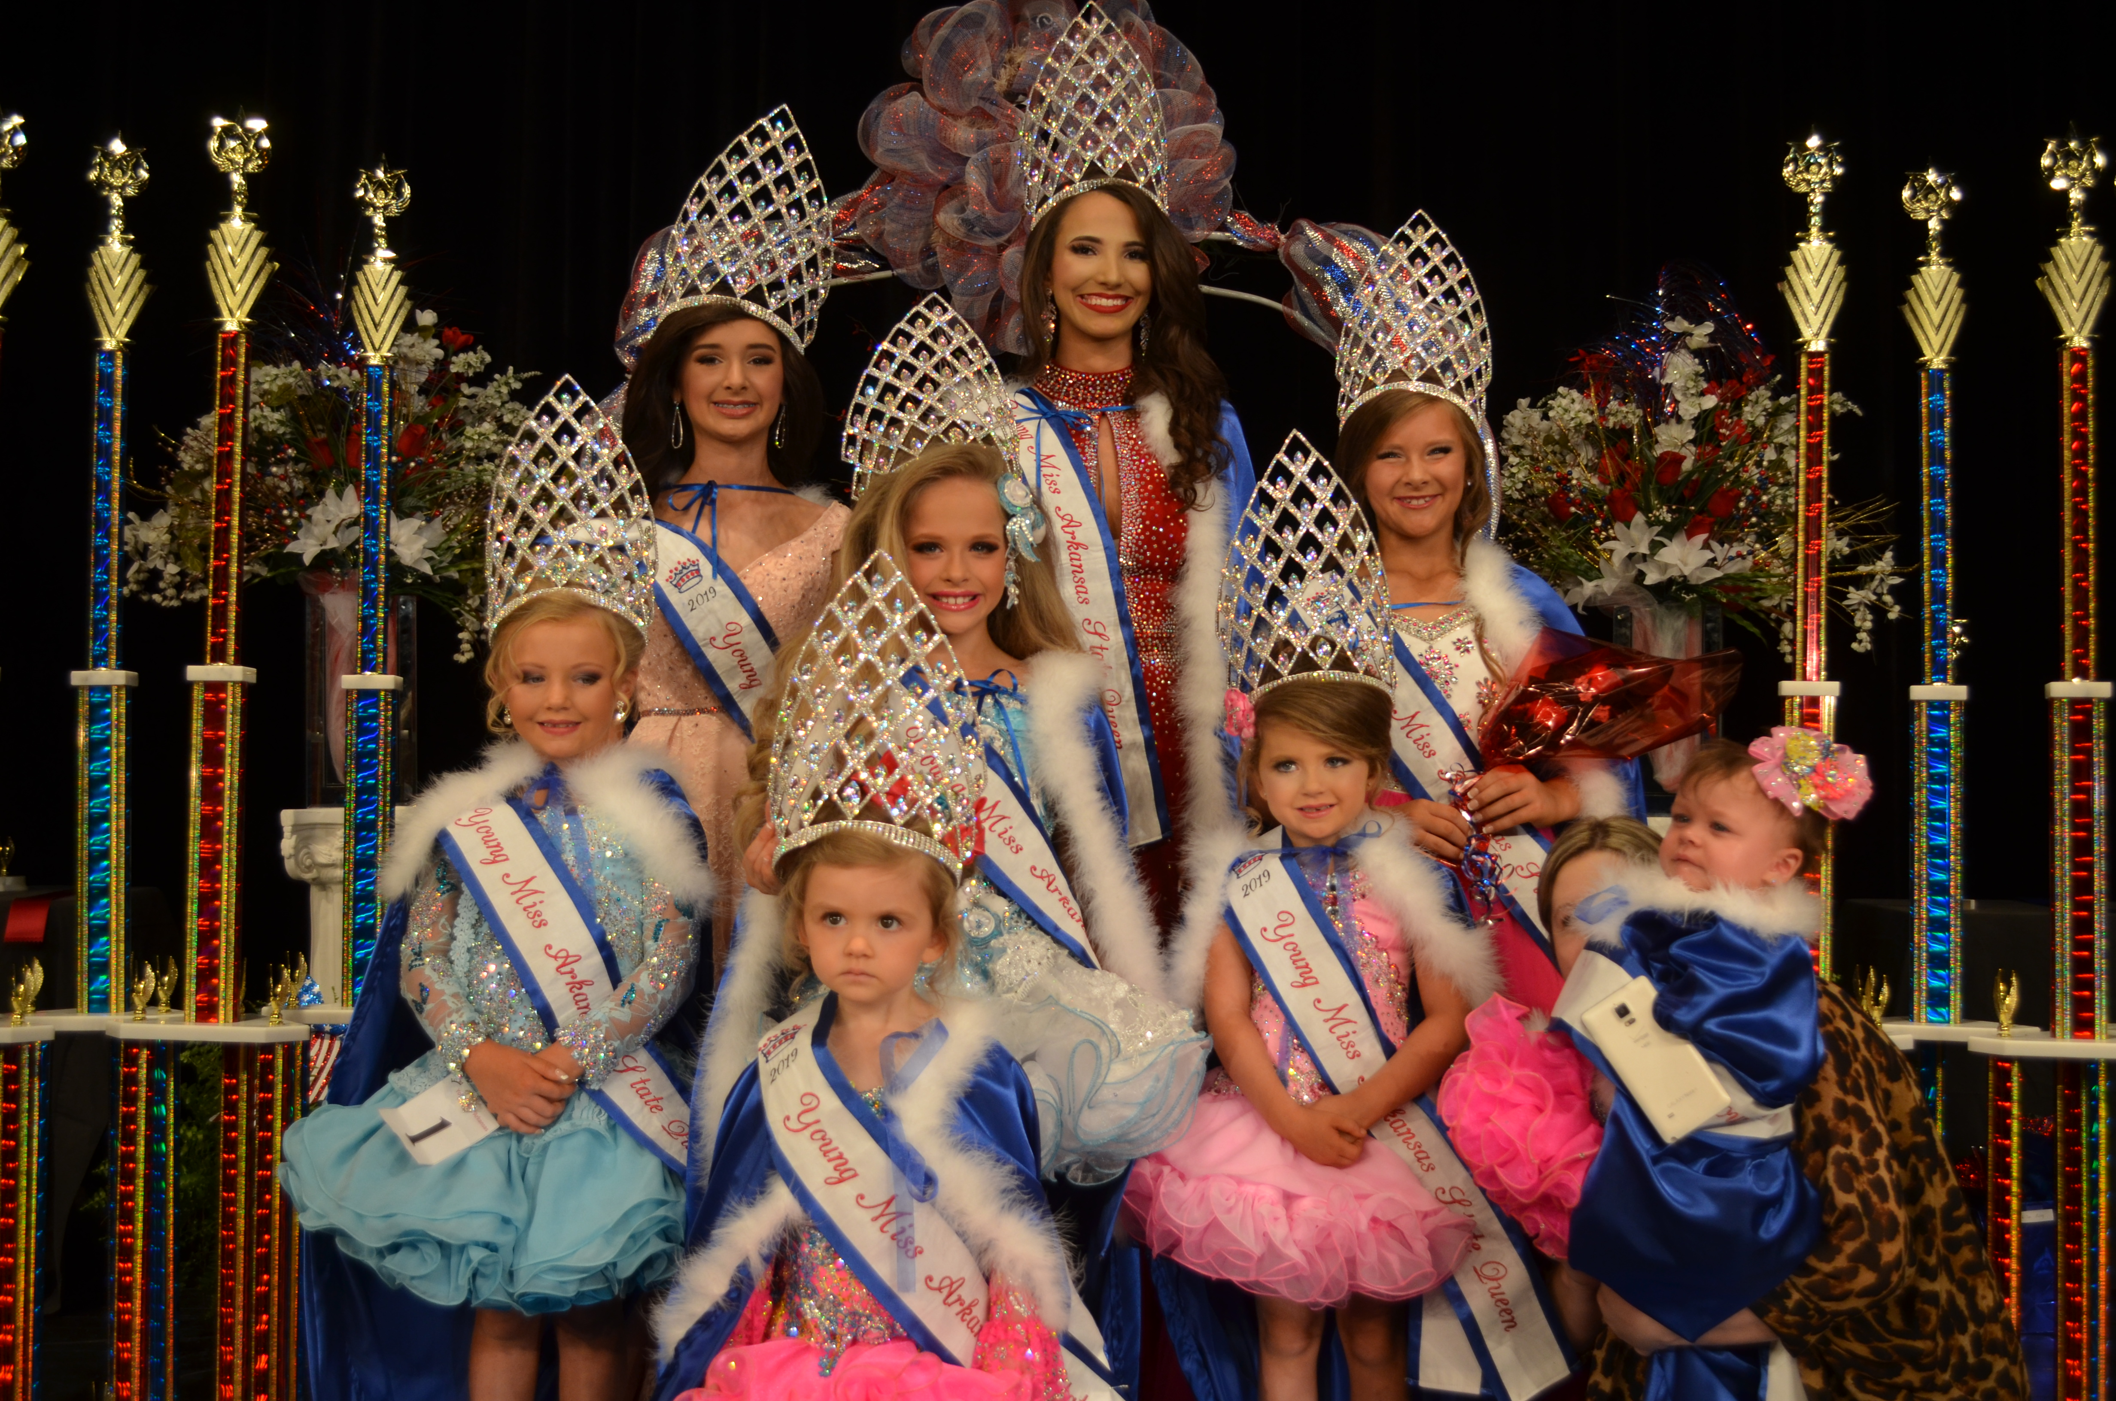

0-23 Mth Queen-Jovie Abbott (Paragould, AR); 2-3 Yr Queen-Alexa Northcutt (Jonesboro, AR);
4-5 Yr Queen-Marley Hitt (Harrisburg, AR); 6-7 Yr Queen-Teagen Strickland (Bay, AR);
8-9 Yr Queen-Savanna Kent (Sherwood, AR); 10-12 Yr Queen-Addyson Oxford (Paragould, AR);
13-15 Yr Queen-Sophie Puckett (Jonesboro, AR); 16-19 Yr Queen-Delaney Nall (Lake City, AR)
AGE DIVISIONS ARE AS FOLLOWS:
Girls: 0-23 MTHS BABY YMA; 2-3 YR TODDLER YMA; 4-5 YR TINY YMA;
6-7 YR PETITE YMA; 8-9 YR YOUNG YMA; 10-12 YR PRETEEN YMA;
13-15 YR JUNIOR YMA; 16-19 YR MISS YMA

DON’T MISS YOUR CHANCE TO WIN ONE OF ARKANSAS’ MOST PRESTIGIOUS TITLES AND BE FEATURED ON NEXT YEARS’ STATE ENTRY FORMS REPRESENTING YOUR AREA. CONTESTANTS COMPETE IN FACIAL BEAUTY, STAGE PRESENCE (EXCLUDING MODELING) AND OVERALL BEAUTY APPEARANCE. ALL CONTESTANTS ARE ENCOURAGED TO PRE- REGISTER BY MAY 8TH, 2020. PLEASE BRING ALL PHOTOS TO PAGEANT LABELED WITH NAME AND AGE ON BACK.

There will be a Queen and 3 Alternates chosen in each division. All Queens will receive a STUNNING

LARGE BUCKET CROWN AND ROSES, 6 FOOT TROPHIES AND BEAUTIFUL MONOGRAMMED BANNERS AND BEAUTIFUL QUEEN ROBES to keep. The 3 Alternates in each division will receive BEAUTIFUL STATE TROPHIES AND BANNERS. SIDE AWARD WINNERS WILL RECEIVE BEAUTIFUL STATE PLAQUES AND BANNERS. A photogenic Queen will be crowned in each division with a BEAUTIFUL CROWN AND BANNER. No modeling scores will be given. Everyone entered in pageant will go home with an award. We ask that each contestant please pre-register prior to the pageant, and pick up their number and leave their photo at the scheduled registration time on pageant day. This will help ensure that our pageant runs more smoothly.

MAIL ALL ENTRY FORMS AND FEES TO: YOUNG MISS ARKANSAS
c/o ALAN & LESIA OLDMAN
798 CR 338 JONESBORO, AR 72401

CERTIFIED FUNDS OR CASH ONLY!!!!!!

DOOR ADMISSION IS $5.00 ADULTS AND $3.00 CHILDREN AGE 12 & UNDER. EVERYONE PAYS ADMISSION EXCEPT THE CONTESTANT. FOR MORE INFO CALL or EMAIL US AT

ALAN OR LESIA OLDMAN AT 870-930-5548; OR 870-974-2032 OR AT eaoldman@yahoo.com

COMPLETE THE INFORMATION BELOW & MAIL WITH FEES TO THE ADDRESS LISTED ABOVE.

BEAUTY$125___(includes Best Dressed, Best Personality, and Most Beautiful)

AMOUNT PAID$___________

PHOTOGENIC$10____(OPTIONAL)____ #ADDITIONAL PHOTOS ENTERED $5___

TICKET SALES (IF ANY) $_____(DUE BY May 2nd, 2020 tickets sales only for additional awards)

AGE DIVISION:___________ AGE:________ CONTESTANT#________(DIRECTORS USE ONLY)

NAME OF CONTESTANT:_________________________________________________________________________

HAIR COLOR:_________________EYE COLOR_________________

HOBBIES:______________________________________________________________________________________

FUTURE PLANS:________________________________________________________________________________

WHO YOU ADMIRE AND WHY:

______________________________________________________________________________________________

______________________________________________________________________________________________

PARENTS NAME__________________________________________________________________

ADDRESS_______________________________CITY____________________ST____ZIP_______PHONE:_________

THERE WILL ALSO BE A MISS CONGENIALITY AWARDED IN THE 8-9, 10-12, 13-15 AND 16-19 AGE GROUPS VOTED ON BY THE CONTESTANTS IN THESE GROUPS . THIS WILL BE AWARDED DURING CROWNING ON STAGE. VOTING FOR EACH CONTESTANT WILL BE DONE DURING LINE UP BACK STAGE BEFORE DIVISION STARTS.

RULES AND REGULATIONS: THIS PAGEANT IS LICENSED AND BOND AS REQUIRED BY LAW UNDER SOUTHERN ANGELIC SYSTEMS.

I UNDERSTAND THAT THIS PAGEANT IS NOT AFFILIATED WITH ANY OTHER STATE PAGEANT TITLES AND THAT THE JUDGES DECISIONS ARE FINAL. I UNDERSTAND THAT ANY SHOW OF BAD SPORTSMANSHIP WILL RESULT IN DISQUALIFICATION WITH NO REFUND. SCORE SHEETS WILL BE AVAILABLE AFTER EACH DIVISION IS CROWNED. I RELEASE ALAN & LESIA OLDMAN, STAFF AND THE WESTSIDE SCHOOL DISTRICT FROM ANY AND ALL LIABILITY FOR ANY ACCIDENT, INJURY OR THEFT THAT MIGHT OCCUR IN CONNECTION WITH TO AND FROM THIS PAGEANT. I UNDERSTAND AND AGREE THAT PHOTOS MAY BE USED FOR ADVERTISEMENT PURPOSES ONLY.

PARENT OR GURADIAN:___________________________________________DATE:________________________

E-mail address:__________________________________________

